WOXSEN UNIVERSITY
School of Technology
LAB ASSIGNMENT - Q49
Node.js Command-Line Tool
Grade Report Generator from CSV Marks
Field | Details
Student Name | Anshu
Roll Number / ID | ____________________
Programme | B.Tech
Course | SDLC - React & Node.js
Assignment | Lab Assignment Q49 (React & Node.js)
Faculty | ____________________
Date of Submission | ____________________

Contents
- Aim
- Objectives
- Problem Statement
- Tools and Technologies
- Project Setup and Structure
- System Design (architecture, flowchart, algorithm)
- Source Code (with screenshots)
- Code Explanation
- How to Run
- Output and Evidence
- Data Visualisation
- Testing (test cases, unit tests, coverage)
- Error Handling
- Publishing as an npm CLI Tool
- Challenges and Solutions
- Future Scope
- Conclusion
- Viva Questions and Answers
- References
- Appendix A - Full Source Code (text)
- Appendix B - README

1. Aim
To design and build a Node.js command-line interface (CLI) tool that reads a CSV file of student marks and prints a complete grade report containing totals, averages, grades, ranks, pass/fail result, subject-wise statistics, toppers, grade distribution and the class average.

2. Objectives
- Parse a CSV file reliably with a standard library instead of splitting strings by hand.
- Build a professional CLI with arguments, options, --help and --version using commander.
- Apply clean code structure: business logic in lib.js and the CLI wrapper in index.js.
- Validate input and report errors with clear messages and a non-zero exit code.
- Add useful options: --top, --pass-mark, --sort, --export, --json and --no-color.
- Verify correctness with automated unit tests and measure code coverage.
- Prepare the project so it can be published and installed from npm.

3. Problem Statement
A teacher has a CSV file in which the first column is the student name and each remaining column is a subject mark. The teacher wants one command that produces a ranked report with grades, pass/fail status, subject averages, subject toppers, the top N students, a grade distribution and the class average, and that can also export the report for use in a spreadsheet.

4. Tools and Technologies
Tool | Purpose
Node.js | JavaScript runtime used to run the tool from the terminal
commander | Parses CLI arguments and options; generates --help and --version
csv-parse | Converts CSV text into JavaScript objects (handles quotes and commas correctly)
node:test + assert | Built-in test runner and assertions used for unit tests and coverage
npm | Package manager used to install dependencies and publish the tool
fs (built-in) | Reads the input file and writes the exported CSV

5. Project Setup and Structure
The project was created with npm init and the two dependencies were installed with npm install.
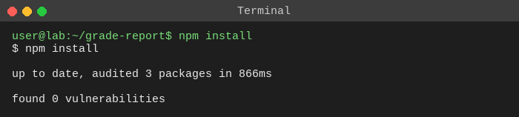
Figure 1: Installing dependencies
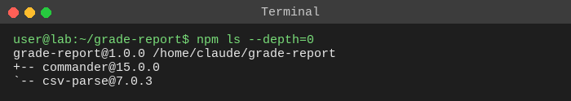
Figure 2: Installed dependencies (npm ls)
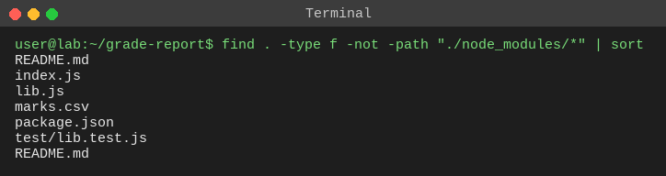
Figure 3: Project file structure
File | Role
index.js | CLI entry point: options, printing, error handling, exit codes
lib.js | Core logic: parseMarks, buildReport, gradeFor, gradeDistribution, sortStudents, toCsv
marks.csv | Sample input data (6 students, 4 subjects)
test/lib.test.js | 10 unit tests for the logic layer
package.json | Dependencies, bin field, npm scripts
README.md | Usage instructions

6. System Design

6.1 Architecture
The tool has two layers. index.js is the interface layer: it reads options, calls the logic layer, prints results and handles errors. lib.js is the logic layer: it contains pure functions with no printing or file access, which makes them easy to test.
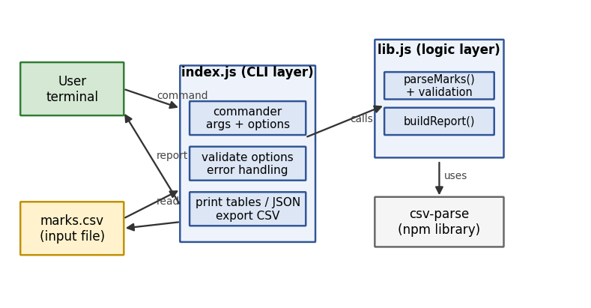
Figure 4: Architecture: CLI layer, logic layer and input file

6.2 Flowchart
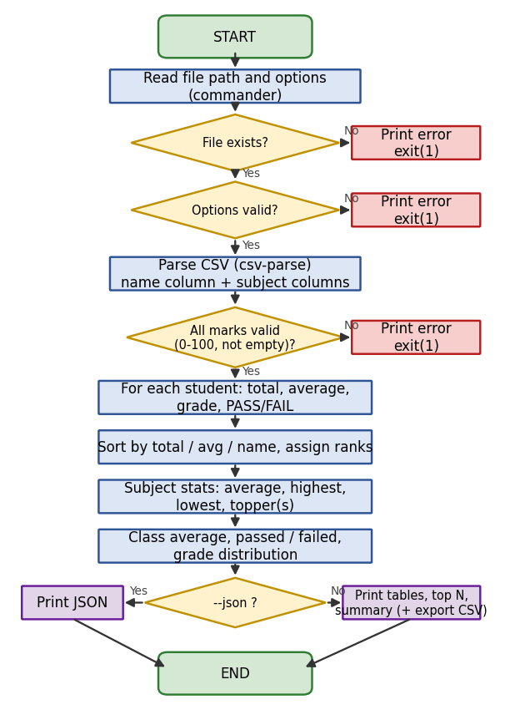
Figure 5: Program flowchart

6.3 Algorithm
- Read the file path given by the user; exit with an error if the file does not exist.
- Validate the options: --top must be a positive integer, --pass-mark must be 0-100, --sort must be total, avg or name.
- Parse the CSV. The first column is the student name; every other column is a subject.
- Validate every mark: it must be a number between 0 and 100 and must not be empty.
- For each student calculate total and average, assign a grade, and mark FAIL if any subject is below the pass mark.
- Sort students and assign ranks (default: highest total first; ties broken alphabetically).
- For each subject calculate average, highest, lowest and topper name(s).
- Calculate class average, number passed/failed and the grade distribution.
- Print tables, top N list, distribution and summary - or JSON if --json is used. Export a CSV if --export is used.

6.4 Grading Scale
Average % | Grade
90 and above | A+
80 - 89.99 | A
70 - 79.99 | B
60 - 69.99 | C
50 - 59.99 | D
Below 50 | F

6.5 Command-Line Options
Option | Description | Default
<file> | Path to the marks CSV (required) | -
-t, --top <n> | Number of toppers to list | 3
-p, --pass-mark <n> | Minimum mark needed in every subject to pass | 40
-s, --sort <by> | Sort order: total, avg or name | total
-e, --export <file> | Save the student table as a CSV file | off
-j, --json | Print the report as JSON | off
--no-color | Disable coloured output | colour on in a terminal
-V, --version | Show version | -
-h, --help | Show help | -

7. Source Code

7.1 marks.csv (sample input)
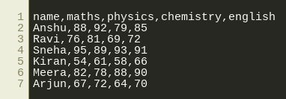
Figure 6: marks.csv

7.2 lib.js - core logic
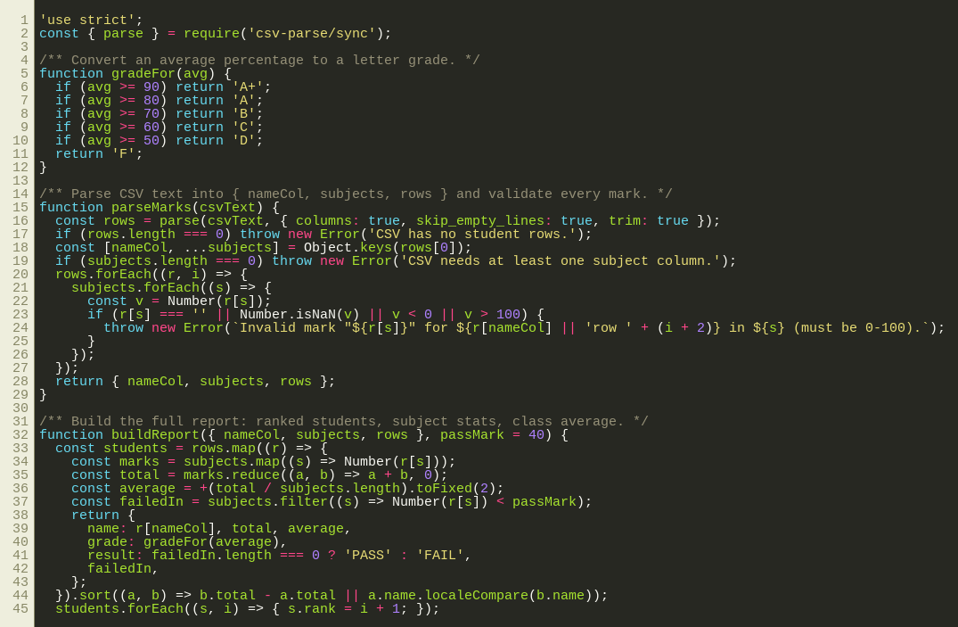
Figure 7: lib.js (part 1)
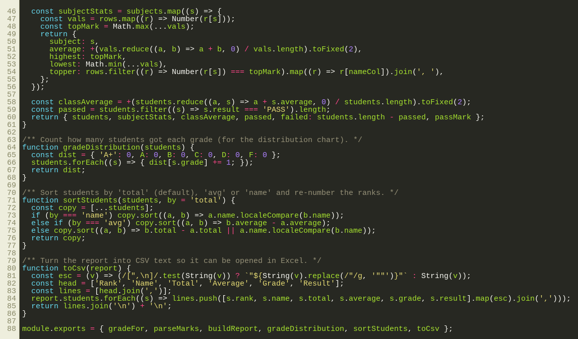
Figure 8: lib.js (part 2)

7.3 index.js - command-line interface
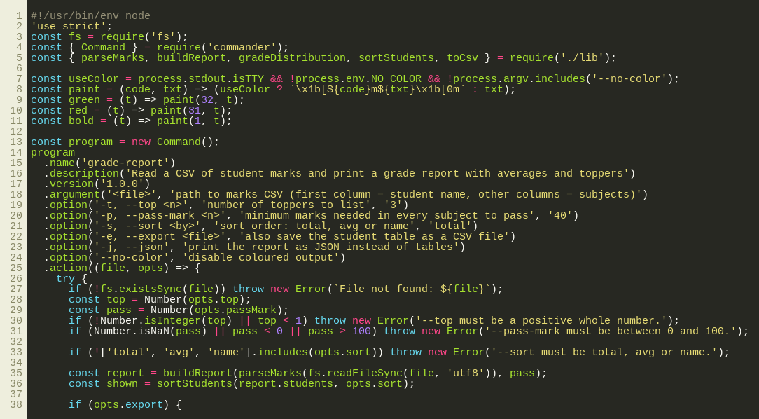
Figure 9: index.js (part 1)
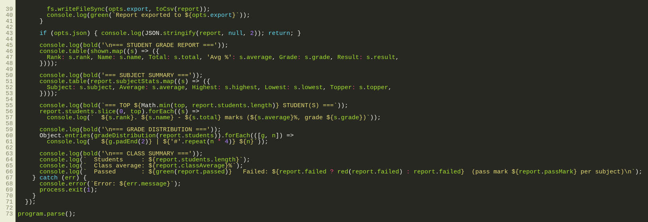
Figure 10: index.js (part 2)

7.4 test/lib.test.js - unit tests
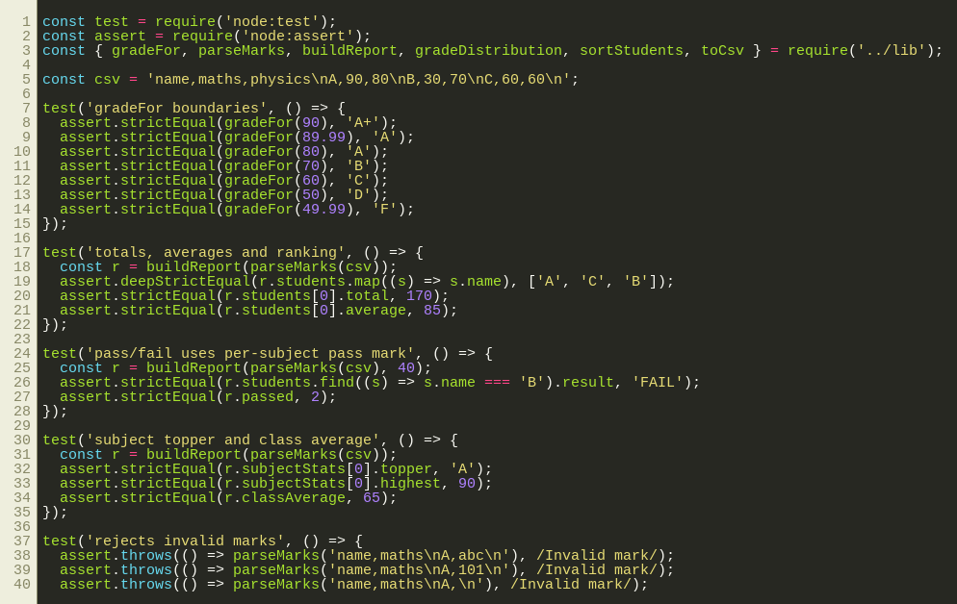
Figure 11: lib.test.js (part 1)
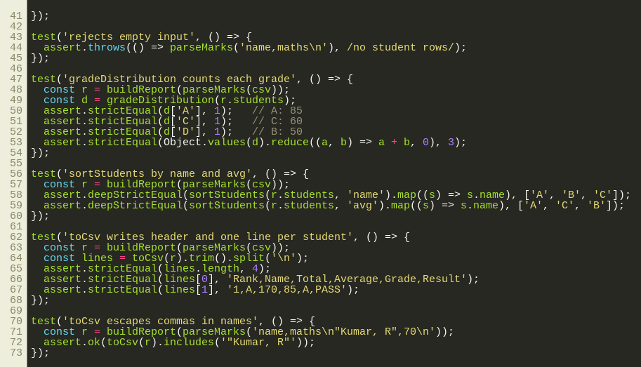
Figure 12: lib.test.js (part 2)

7.5 package.json
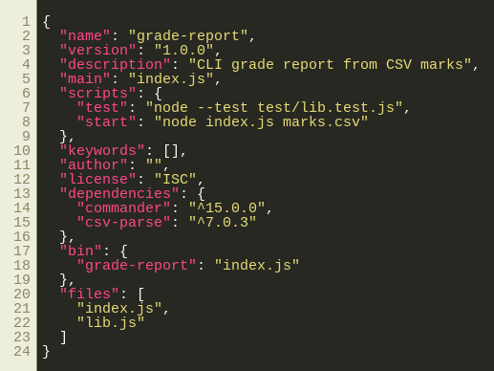
Figure 13: package.json

8. Code Explanation
Function / part | What it does
gradeFor(avg) | Maps an average percentage to a letter grade using the grading scale.
parseMarks(csvText) | Parses CSV text with csv-parse (columns:true, trim, skip empty lines). Takes the first column as the name column and the rest as subjects. Throws an error for empty files and for any mark that is empty, not a number, or outside 0-100.
buildReport(data, passMark) | Calculates total, average, grade and PASS/FAIL for each student; sorts and ranks; calculates per-subject average, highest, lowest and topper(s); and the class average with pass/fail counts.
gradeDistribution(students) | Counts how many students received each grade (used for the distribution bars).
sortStudents(students, by) | Returns a copy sorted by total, average or name (does not change the original array).
toCsv(report) | Builds CSV text for export; values containing commas or quotes are escaped correctly.
index.js action() | Validates options, reads the file, builds the report and prints it. All errors are caught in one try/catch which prints "Error: ..." and exits with code 1.
Colour helpers | ANSI colour codes are used only when the output is a terminal and --no-color / NO_COLOR is not set, so piped output stays clean.

9. How to Run
npm install
node index.js marks.csv
node index.js marks.csv --top 5 --pass-mark 50
node index.js marks.csv --sort name
node index.js marks.csv --export report.csv
node index.js marks.csv --json
node index.js --help
npm test

10. Output and Evidence

10.1 Help and version
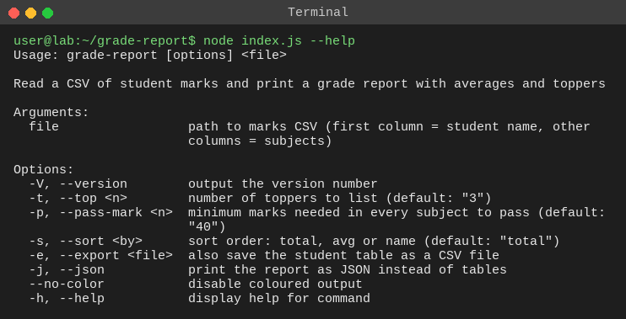
Figure 14: grade-report --help
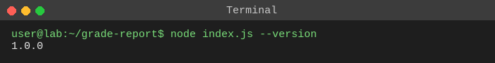
Figure 15: grade-report --version

10.2 Default run
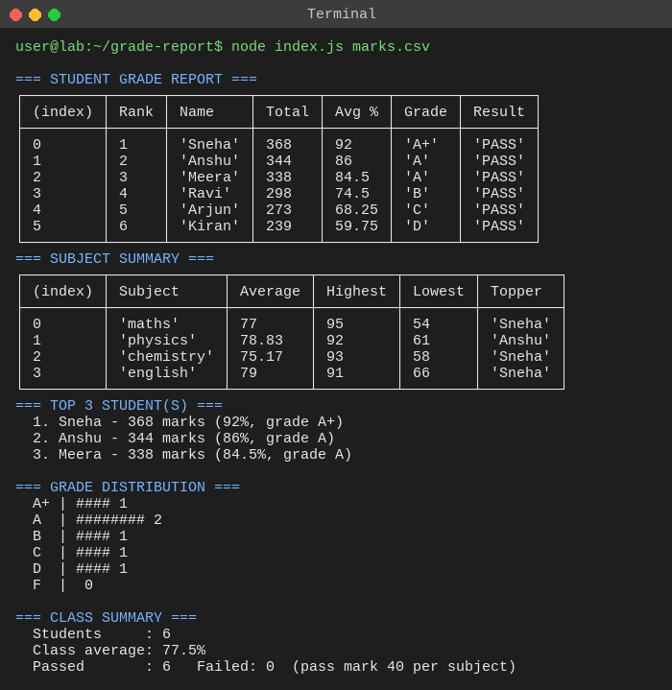
Figure 16: Full grade report with default options

10.3 Custom options: --top 2 --pass-mark 60
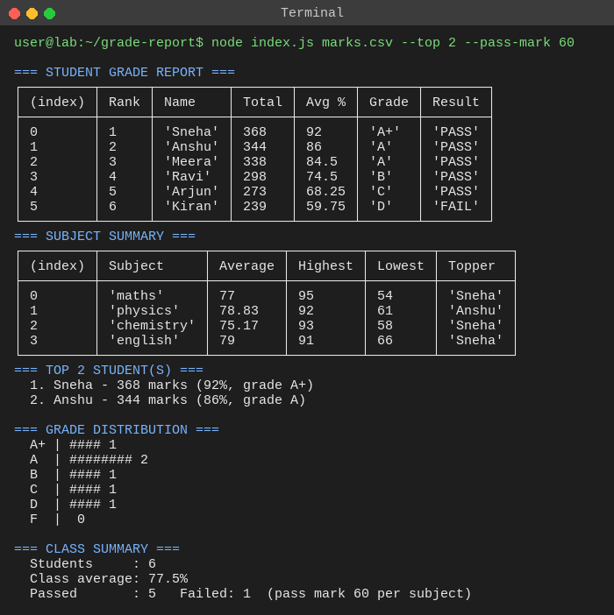
Figure 17: Pass mark 60: Kiran fails (below 60 in Chemistry)

10.4 Sorting by name
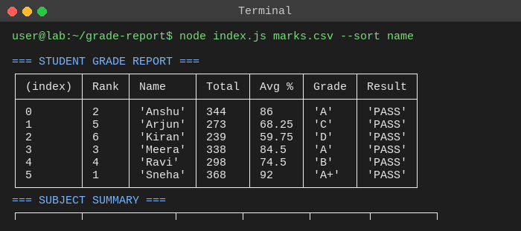
Figure 18: --sort name

10.5 Exporting to CSV
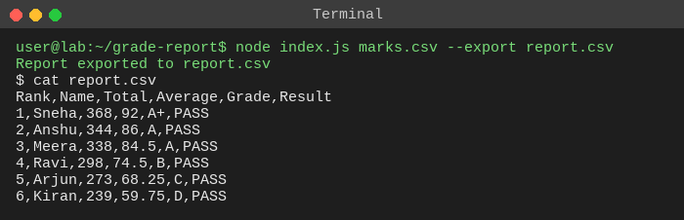
Figure 19: --export report.csv
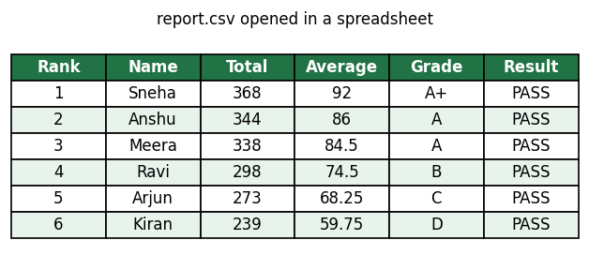
Figure 20: Exported report.csv opened in a spreadsheet

10.6 JSON output
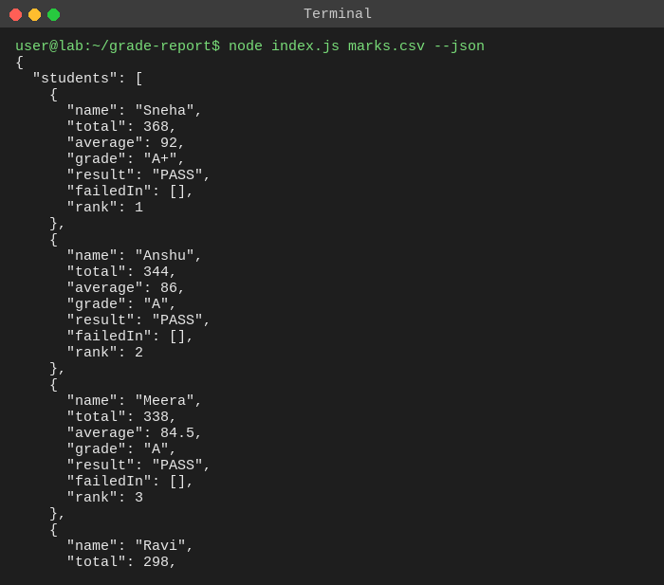
Figure 21: --json (first 32 lines)

11. Data Visualisation
The charts below were drawn from the same marks.csv data to show what the report contains.
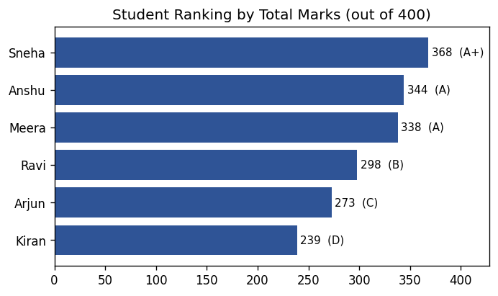
Figure 22: Student ranking by total marks
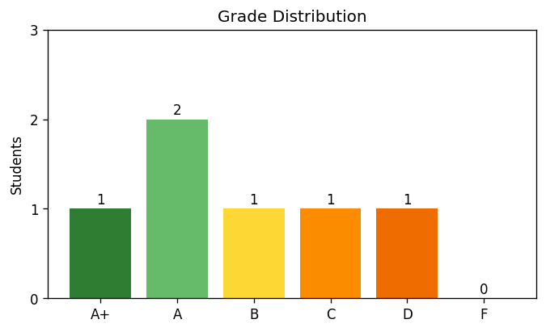
Figure 23: Grade distribution
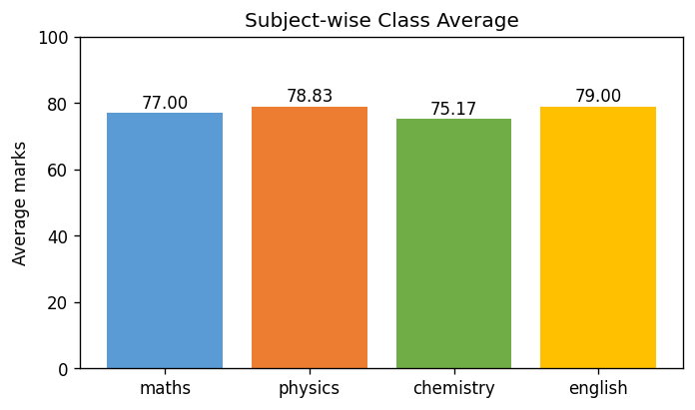
Figure 24: Subject-wise class average
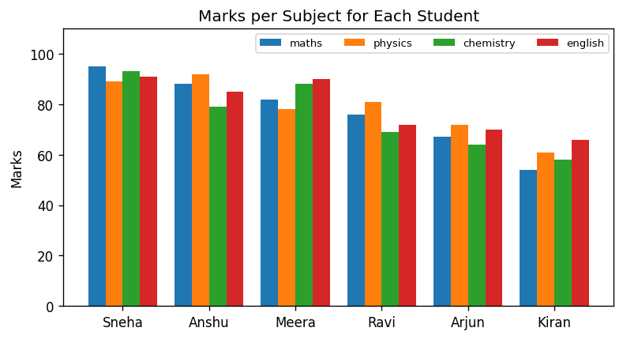
Figure 25: Marks per subject for each student

12. Testing

12.1 Test cases
# | Test case | Expected result | Status
1 | Valid marks.csv | Ranked table, subject summary, top 3, distribution, class summary | Pass
2 | --top 2 | Only 2 toppers listed | Pass
3 | --pass-mark 60 | Students below 60 in any subject marked FAIL | Pass
4 | --sort name | Students listed alphabetically | Pass
5 | --export report.csv | CSV file created with header and one row per student | Pass
6 | --json | Valid JSON report printed | Pass
7 | Non-existent file | "File not found" error, exit code 1 | Pass
8 | Mark = "abc" | "Invalid mark" error, exit code 1 | Pass
9 | --top 0 | "--top must be a positive whole number", exit code 1 | Pass
10 | --sort rank | "--sort must be total, avg or name", exit code 1 | Pass
11 | CSV with header only | "CSV has no student rows", exit code 1 | Pass
12 | Mark above 100 / empty mark | Rejected by validation (unit test) | Pass
13 | Grade boundaries 90/80/70/60/50 | Correct grade at each boundary (unit test) | Pass
14 | Name containing a comma | Escaped correctly in exported CSV (unit test) | Pass

12.2 Unit tests
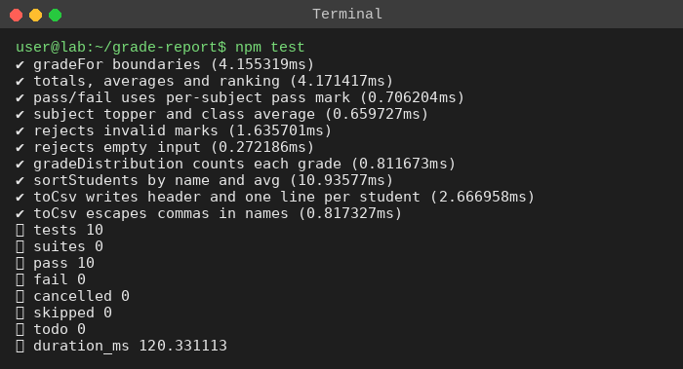
Figure 26: All 10 unit tests passing (npm test)

12.3 Code coverage
Node's built-in coverage report shows 98.88% line coverage for lib.js.
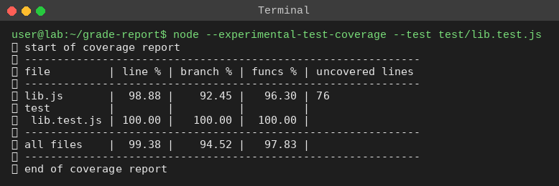
Figure 27: Coverage report

13. Error Handling
Every error is shown as one clear line and the program exits with code 1, so scripts and CI pipelines can detect failure.
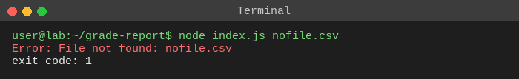
Figure 28: Missing file
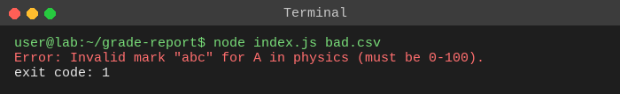
Figure 29: Invalid mark in CSV
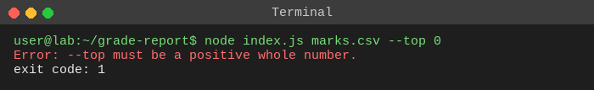
Figure 30: Invalid --top value
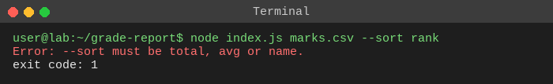
Figure 31: Invalid --sort value
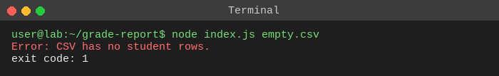
Figure 32: CSV with no student rows

14. Publishing as an npm CLI Tool
package.json contains a "bin" field mapping the command grade-report to index.js, and index.js begins with the shebang line #!/usr/bin/env node so the operating system runs it with Node.
- npm link (test the global command locally)
- npm login
- npm publish
- npm install -g grade-report (users then run: grade-report marks.csv)

15. Challenges and Solutions
Challenge | Solution
CSV values with commas or quotes break simple splitting | Used the csv-parse library which follows the CSV standard.
Wrong data silently gives NaN averages | Validated every mark (number, 0-100, not empty) and fail early with a clear message.
Hard to test code that prints | Moved the logic into pure functions in lib.js and kept printing in index.js.
Colour codes spoil piped or redirected output | Colour is enabled only for a terminal and can be switched off with --no-color.
Students with equal totals | Ties are broken alphabetically so the order is always the same.

16. Future Scope
- Read Excel (.xlsx) files and export to PDF.
- Weighted subjects and configurable grade boundaries from a config file.
- Interactive mode and a web dashboard that uses the --json output.
- Continuous integration with GitHub Actions to run the tests on every push.

17. Conclusion
The tool reads marks from a CSV file and produces a ranked grade report with grades, pass/fail results, subject statistics, toppers, a grade distribution and a class average. Separating logic (lib.js) from the interface (index.js) made the code testable: ten unit tests with about 99% line coverage verify grading, ranking, sorting, export and validation. Clear error messages and exit codes make the tool safe to use in scripts, and the package is ready to publish to npm.

18. Viva Questions and Answers
Q1. How do you publish a CLI tool with npm?
Add a "bin" field in package.json pointing to the entry file, put #!/usr/bin/env node at the top of that file, run npm login and then npm publish. Users install it with npm install -g and run it by the command name.
Q2. What is the purpose of the shebang line?
It tells Unix-like systems which interpreter runs the file. #!/usr/bin/env node finds Node in the user's PATH so the file can be run directly as a command. On Windows, npm creates a wrapper script.
Q3. Why use commander instead of reading process.argv directly?
Commander parses arguments and options, validates them, and generates --help and --version automatically. Doing it manually with process.argv is error-prone and gives no standard help output.
Q4. Why use csv-parse instead of split(",")?
CSV fields can contain quoted commas, quotes and newlines, which split(",") breaks. csv-parse follows the CSV standard; with columns:true it returns each row as an object keyed by the header.
Q5. Why separate lib.js and index.js?
lib.js has pure functions with no printing or file access, so they are easy to unit test. index.js handles only CLI concerns (arguments, printing, exit codes). This is separation of concerns.
Q6. How does the tool decide pass or fail?
A student passes only if the mark in every subject is at or above the pass mark (default 40, changeable with --pass-mark). The grade is based on the average percentage.
Q7. How are ties in total marks handled?
Students are sorted by total in descending order; equal totals are ordered alphabetically. If two students share the highest mark in a subject, both are listed as toppers.
Q8. What does process.exit(1) mean?
Exit code 0 means success; any non-zero code means failure. Returning 1 on errors lets shell scripts and CI pipelines detect that the tool failed.
Q9. Why validate the marks?
Bad data (letters, blanks, values above 100) would silently produce NaN or wrong averages. Failing early with a clear message prevents wrong reports.
Q10. Why use readFileSync instead of readFile?
readFileSync blocks until the file is read. For a short-lived CLI that needs the file before doing anything else, it is simple and fine. In a server it would block the event loop, so an async version would be used.
Q11. What is the difference between dependencies and devDependencies?
dependencies are needed to run the tool (commander, csv-parse). devDependencies are only for development, such as test or lint tools. Here the tests use Node's built-in runner, so no devDependencies are needed.
Q12. What does npm link do?
It creates a global symlink to the local project so the command works from anywhere while developing, without publishing.
Q13. How did you test the tool?
With ten unit tests using Node's built-in test runner covering grade boundaries, ranking, pass/fail, toppers, class average, sorting, CSV export and invalid input, plus manual CLI runs for each option and error case. Coverage of lib.js is about 99%.
Q14. Why does coloured output need a TTY check?
ANSI colour codes look like garbage characters when output is redirected to a file or another program. Checking process.stdout.isTTY keeps piped output clean.
Q15. How can this tool be improved?
Support Excel input, export to PDF, weighted subjects, configurable grade boundaries, and add CI to run tests automatically.

19. References
- Node.js documentation - https://nodejs.org/docs
- commander.js - https://github.com/tj/commander.js
- csv-parse (node-csv) - https://csv.js.org/parse/
- npm documentation: package.json "bin" field - https://docs.npmjs.com/cli/configuring-npm/package-json
- Node.js test runner - https://nodejs.org/api/test.html

Appendix A - Full Source Code (text)

lib.js
'use strict';
const { parse } = require('csv-parse/sync');

/** Convert an average percentage to a letter grade. */
function gradeFor(avg) {
if (avg >= 90) return 'A+';
if (avg >= 80) return 'A';
if (avg >= 70) return 'B';
if (avg >= 60) return 'C';
if (avg >= 50) return 'D';
return 'F';
}

/** Parse CSV text into { nameCol, subjects, rows } and validate every mark. */
function parseMarks(csvText) {
const rows = parse(csvText, { columns: true, skip_empty_lines: true, trim: true });
if (rows.length === 0) throw new Error('CSV has no student rows.');
const [nameCol, ...subjects] = Object.keys(rows[0]);
if (subjects.length === 0) throw new Error('CSV needs at least one subject column.');
rows.forEach((r, i) => {
subjects.forEach((s) => {
const v = Number(r[s]);
if (r[s] === '' || Number.isNaN(v) || v < 0 || v > 100) {
throw new Error(`Invalid mark "${r[s]}" for ${r[nameCol] || 'row ' + (i + 2)} in ${s} (must be 0-100).`);
}
});
});
return { nameCol, subjects, rows };
}

/** Build the full report: ranked students, subject stats, class average. */
function buildReport({ nameCol, subjects, rows }, passMark = 40) {
const students = rows.map((r) => {
const marks = subjects.map((s) => Number(r[s]));
const total = marks.reduce((a, b) => a + b, 0);
const average = +(total / subjects.length).toFixed(2);
const failedIn = subjects.filter((s) => Number(r[s]) < passMark);
return {
name: r[nameCol], total, average,
grade: gradeFor(average),
result: failedIn.length === 0 ? 'PASS' : 'FAIL',
failedIn,
};
}).sort((a, b) => b.total - a.total || a.name.localeCompare(b.name));
students.forEach((s, i) => { s.rank = i + 1; });

const subjectStats = subjects.map((s) => {
const vals = rows.map((r) => Number(r[s]));
const topMark = Math.max(...vals);
return {
subject: s,
average: +(vals.reduce((a, b) => a + b, 0) / vals.length).toFixed(2),
highest: topMark,
lowest: Math.min(...vals),
topper: rows.filter((r) => Number(r[s]) === topMark).map((r) => r[nameCol]).join(', '),
};
});

const classAverage = +(students.reduce((a, s) => a + s.average, 0) / students.length).toFixed(2);
const passed = students.filter((s) => s.result === 'PASS').length;
return { students, subjectStats, classAverage, passed, failed: students.length - passed, passMark };
}

/** Count how many students got each grade (for the distribution chart). */
function gradeDistribution(students) {
const dist = { 'A+': 0, A: 0, B: 0, C: 0, D: 0, F: 0 };
students.forEach((s) => { dist[s.grade] += 1; });
return dist;
}

/** Sort students by 'total' (default), 'avg' or 'name' and re-number the ranks. */
function sortStudents(students, by = 'total') {
const copy = [...students];
if (by === 'name') copy.sort((a, b) => a.name.localeCompare(b.name));
else if (by === 'avg') copy.sort((a, b) => b.average - a.average);
else copy.sort((a, b) => b.total - a.total || a.name.localeCompare(b.name));
return copy;
}

/** Turn the report into CSV text so it can be opened in Excel. */
function toCsv(report) {
const esc = (v) => (/[",\n]/.test(String(v)) ? `"${String(v).replace(/"/g, '""')}"` : String(v));
const head = ['Rank', 'Name', 'Total', 'Average', 'Grade', 'Result'];
const lines = [head.join(',')];
report.students.forEach((s) => lines.push([s.rank, s.name, s.total, s.average, s.grade, s.result].map(esc).join(',')));
return lines.join('\n') + '\n';
}

module.exports = { gradeFor, parseMarks, buildReport, gradeDistribution, sortStudents, toCsv };

index.js
#!/usr/bin/env node
'use strict';
const fs = require('fs');
const { Command } = require('commander');
const { parseMarks, buildReport, gradeDistribution, sortStudents, toCsv } = require('./lib');

const useColor = process.stdout.isTTY && !process.env.NO_COLOR && !process.argv.includes('--no-color');
const paint = (code, txt) => (useColor ? `\x1b[${code}m${txt}\x1b[0m` : txt);
const green = (t) => paint(32, t);
const red = (t) => paint(31, t);
const bold = (t) => paint(1, t);

const program = new Command();
program
.name('grade-report')
.description('Read a CSV of student marks and print a grade report with averages and toppers')
.version('1.0.0')
.argument('<file>', 'path to marks CSV (first column = student name, other columns = subjects)')
.option('-t, --top <n>', 'number of toppers to list', '3')
.option('-p, --pass-mark <n>', 'minimum marks needed in every subject to pass', '40')
.option('-s, --sort <by>', 'sort order: total, avg or name', 'total')
.option('-e, --export <file>', 'also save the student table as a CSV file')
.option('-j, --json', 'print the report as JSON instead of tables')
.option('--no-color', 'disable coloured output')
.action((file, opts) => {
try {
if (!fs.existsSync(file)) throw new Error(`File not found: ${file}`);
const top = Number(opts.top);
const pass = Number(opts.passMark);
if (!Number.isInteger(top) || top < 1) throw new Error('--top must be a positive whole number.');
if (Number.isNaN(pass) || pass < 0 || pass > 100) throw new Error('--pass-mark must be between 0 and 100.');

if (!['total', 'avg', 'name'].includes(opts.sort)) throw new Error('--sort must be total, avg or name.');

const report = buildReport(parseMarks(fs.readFileSync(file, 'utf8')), pass);
const shown = sortStudents(report.students, opts.sort);

if (opts.export) {
fs.writeFileSync(opts.export, toCsv(report));
console.log(green(`Report exported to ${opts.export}`));
}

if (opts.json) { console.log(JSON.stringify(report, null, 2)); return; }

console.log(bold('\n=== STUDENT GRADE REPORT ==='));
console.table(shown.map((s) => ({
Rank: s.rank, Name: s.name, Total: s.total, 'Avg %': s.average, Grade: s.grade, Result: s.result,
})));

console.log(bold('=== SUBJECT SUMMARY ==='));
console.table(report.subjectStats.map((s) => ({
Subject: s.subject, Average: s.average, Highest: s.highest, Lowest: s.lowest, Topper: s.topper,
})));

console.log(bold(`=== TOP ${Math.min(top, report.students.length)} STUDENT(S) ===`));
report.students.slice(0, top).forEach((s) =>
console.log(` ${s.rank}. ${s.name} - ${s.total} marks (${s.average}%, grade ${s.grade})`));

console.log(bold('\n=== GRADE DISTRIBUTION ==='));
Object.entries(gradeDistribution(report.students)).forEach(([g, n]) =>
console.log(` ${g.padEnd(2)} | ${'#'.repeat(n * 4)} ${n}`));

console.log(bold('\n=== CLASS SUMMARY ==='));
console.log(` Students : ${report.students.length}`);
console.log(` Class average: ${report.classAverage}%`);
console.log(` Passed : ${green(report.passed)} Failed: ${report.failed ? red(report.failed) : report.failed} (pass mark ${report.passMark} per subject)\n`);
} catch (err) {
console.error(`Error: ${err.message}`);
process.exit(1);
}
});

program.parse();

test/lib.test.js
const test = require('node:test');
const assert = require('node:assert');
const { gradeFor, parseMarks, buildReport, gradeDistribution, sortStudents, toCsv } = require('../lib');

const csv = 'name,maths,physics\nA,90,80\nB,30,70\nC,60,60\n';

test('gradeFor boundaries', () => {
assert.strictEqual(gradeFor(90), 'A+');
assert.strictEqual(gradeFor(89.99), 'A');
assert.strictEqual(gradeFor(80), 'A');
assert.strictEqual(gradeFor(70), 'B');
assert.strictEqual(gradeFor(60), 'C');
assert.strictEqual(gradeFor(50), 'D');
assert.strictEqual(gradeFor(49.99), 'F');
});

test('totals, averages and ranking', () => {
const r = buildReport(parseMarks(csv));
assert.deepStrictEqual(r.students.map((s) => s.name), ['A', 'C', 'B']);
assert.strictEqual(r.students[0].total, 170);
assert.strictEqual(r.students[0].average, 85);
});

test('pass/fail uses per-subject pass mark', () => {
const r = buildReport(parseMarks(csv), 40);
assert.strictEqual(r.students.find((s) => s.name === 'B').result, 'FAIL');
assert.strictEqual(r.passed, 2);
});

test('subject topper and class average', () => {
const r = buildReport(parseMarks(csv));
assert.strictEqual(r.subjectStats[0].topper, 'A');
assert.strictEqual(r.subjectStats[0].highest, 90);
assert.strictEqual(r.classAverage, 65);
});

test('rejects invalid marks', () => {
assert.throws(() => parseMarks('name,maths\nA,abc\n'), /Invalid mark/);
assert.throws(() => parseMarks('name,maths\nA,101\n'), /Invalid mark/);
assert.throws(() => parseMarks('name,maths\nA,\n'), /Invalid mark/);
});

test('rejects empty input', () => {
assert.throws(() => parseMarks('name,maths\n'), /no student rows/);
});

test('gradeDistribution counts each grade', () => {
const r = buildReport(parseMarks(csv));
const d = gradeDistribution(r.students);
assert.strictEqual(d['A'], 1); // A: 85
assert.strictEqual(d['C'], 1); // C: 60
assert.strictEqual(d['D'], 1); // B: 50
assert.strictEqual(Object.values(d).reduce((a, b) => a + b, 0), 3);
});

test('sortStudents by name and avg', () => {
const r = buildReport(parseMarks(csv));
assert.deepStrictEqual(sortStudents(r.students, 'name').map((s) => s.name), ['A', 'B', 'C']);
assert.deepStrictEqual(sortStudents(r.students, 'avg').map((s) => s.name), ['A', 'C', 'B']);
});

test('toCsv writes header and one line per student', () => {
const r = buildReport(parseMarks(csv));
const lines = toCsv(r).trim().split('\n');
assert.strictEqual(lines.length, 4);
assert.strictEqual(lines[0], 'Rank,Name,Total,Average,Grade,Result');
assert.strictEqual(lines[1], '1,A,170,85,A,PASS');
});

test('toCsv escapes commas in names', () => {
const r = buildReport(parseMarks('name,maths\n"Kumar, R",70\n'));
assert.ok(toCsv(r).includes('"Kumar, R"'));
});

package.json
{
"name": "grade-report",
"version": "1.0.0",
"description": "CLI grade report from CSV marks",
"main": "index.js",
"scripts": {
"test": "node --test test/lib.test.js",
"start": "node index.js marks.csv"
},
"keywords": [],
"author": "",
"license": "ISC",
"dependencies": {
"commander": "^15.0.0",
"csv-parse": "^7.0.3"
},
"bin": {
"grade-report": "index.js"
},
"files": [
"index.js",
"lib.js"
]
}

marks.csv
name,maths,physics,chemistry,english
Anshu,88,92,79,85
Ravi,76,81,69,72
Sneha,95,89,93,91
Kiran,54,61,58,66
Meera,82,78,88,90
Arjun,67,72,64,70

Appendix B - README
# grade-report

Node.js CLI that reads a CSV of student marks and prints a grade report: ranks, totals, averages, grades, pass/fail, subject-wise statistics, toppers and class average.

## Install & run
npm install
node index.js marks.csv
node index.js marks.csv --top 5 --pass-mark 50
node index.js marks.csv --json
npm test

## CSV format
First column = student name, remaining columns = subjects (marks 0-100).

## Publish to npm
`package.json` has a `bin` field and `index.js` starts with `#!/usr/bin/env node`. Run `npm login` then `npm publish`.

